Historical development of SMMI in Bangladesh

Our first mission in Dhaka

As the days passed by, the good works of the CMMI (in today’s world known as SMMI) attract the hearts of people, priests and Bishop of the places. The fragrance spread far and wide faster. At that time Dhaka (Bengal) was a part of India territory and it was a Catholic diocese. It was at the request of Bishop Hurth, Bishop of Dhaka that Fr. Henri Chaumont had sent seven sisters of Catechists Missionaries of Mary Immaculate headed by Mother Therese of the Epiphany to Bengal.They left Paris in December 1895 and reached Dhaka, Bengal in 1896. On their way to Bengal they stopped for a few days at the cradle of our mission Nagpur and also to meet Mother Marie Gertrude, the Assistant for the Missions of CMMIs. Along with Mother Therese of the Epiphany Sr Pauline of the Eucharist, Sr. Lucie of the Heart of Jesus, Sr. Berchmans of the Eucharist, Sr Agnes of the Spirit of Jesus, Sr Madeleine Caroline and Sr Vincent of the Holy Spirit were the courageous first pioneers to this land.

Under the guidance of Mother Therese of the Epiphany, Sisters started their mission in Dhaka, Luxmibazar. St. Xavier Anglo-Indian School which was already ran by the Holy Cross Sisters, our Sisters had to take up relieving the Holy Cross Sisters recalled to the States where they have an immense work. However it had been decided through the kindness of the Superior that Sr Paula, CSC would stay for a year to accompany our Sisters to initiate them the management of the school, to introduce them to some friendly families and to teach them English. Brother Eugene, CSC was assigned to teach them Bengali. Soon they could start teaching work, take care of the young girls having their board at the convent and dispense some medicine. Later our Sisters also taught in St. Gregory School.

In the Annals of Holy Cross Fathers for Dhaka Mission we read this, ‘Sister Madeleine directed the Anglo-Indian school in 1900. Attached to the school academy was an omnibus institution which had a home for the aged. On the same ground the crèche, the cradle department for the orphans and unwanted children. Next was the work room, a happy name for the Rescue Home, where motherly attention was given to widows or others who thought to regain the narrow path. Finally there was an Institution which is not common in Christian land. It was a Home more properly a shelter for the gentle type of non-Christian beggars whose love for freedom and their pronounced distant for work, disqualified them for membership in the work room. The population who frequented the shelter were the aged and the diseased. While in health, these poor people would absent themselves from the shelter for days and weeks to visit sacred places of the Ganges. At these holy places pilgrims were accustomed to assemble together; consequently, alms seekers, professionals and others may reap a finest harvest. Sister Madeleine would not be anxious, she knew by experience that her dear people could manage to return to the shelter for the off season. When their ages and infirmities made their wandering impossible, these ends of humanity would consent to end their life at the home care for by the Sisters and find the way to heaven. Leper cases were attended too by the Sisters and it is in taking care of a little leper patient that Sister Caroline contacted the terrible disease. She was taken by Sister Madeleine to a specialist in Kolkata who could only confirm the diagnostic of Dhaka Doctor. Sister Caroline was sent to our Leprosarium, South India held by SMMI Sisters where Sister Marie Britto, a Goan Sister also was suffering from Leprosy. After some years, Sister Caroline died there in 1933 and her companion recovered. Sister Caroline was a model of endurance and apostolic zeal.’
Mother Marie Gertrude’s first visit to Bengal

Mother Marie Gertrude, the Co-Foundress of CMMI was in France. Her return to India, to visit the new mission in Dhaka was decided in March 1896. On that very day at 9:00 pm the Sisters in Dhaka were suddenly alarmed when doors and windows of their dormitory were violently shaken. Taking into account the difference of timing, the Superiors in Paris came to realise that the noise occurred exactly at the moment the decision was taken. Back to India, Mother Marie Gertrude dose not forget her mandate to visit Dhaka community. In spite of the difficulties of the journey and of her bad health, she starts soon after the first showers of the monsoon. Her coming will open to her Sisters the special way of their apostolate: touring of distant villages and question of such outings is taken with the Bishop. Respectfully Mother Marie Gertrude insists: ‘ … to carry the Gospel is not a boat as good as a bullock cart?’ So, we keep in mind the picture of the Missionaries sailing on a boat flying the flag of Mary Immaculate!

They used to visit villages by bullock-carts and during Rainy season by boats. It is good to mention that there is a river-port Sadarghat very near to the Convent. They used to go to remain for 8/10 days carrying with them the necessary things and some posters, pictures, slide show for catechism classes. These journeys were difficult on account of the network of canals delta of the river Ganges. But the Sisters knew very well that Mary Immaculate always watched over them and sheltered them from all dangers. Always a catechist teacher used to accompany them. They used to prepare children and adults in villages for the Sacraments of initiation: first Communion, Confirmation and Marriage. During rainy season Sisters could not go to the far villages, at that time they would devote themselves to the lepers, young children and the women those who were in our compound. Everything would be possible because they would draw strength from the Holy Sacrament. Through their personal prayers, reflections of the Word of God they could prepare themselves for those difficult and challenging works.

Natural calamities

After a year and half of their arrival in Bengal, a terrible earthquake occurred in Dhaka on June 12, 1897 around 5:00 pm and caused much destruction. We read in the diocese records: ‘It was Sunday, 12th June at 5:00 pm a dull rambling sound was heard in the distance, nearing the city slowly. There was not a cloud in the sky, only a deep laden haze. The noise came nearer and increased in volume. Then could be seen a sight that filled everyone with terror; trees were rising at a distance like mats in a stormy sea. Hissing sounds like escaping steam punctuated the rambling. The waves were upon us men and beasts were staggering as if drunk and falling on the ground. The air was filled with shouting, everyone calling to his God for help … Meanwhile the Bishop, Priests, Sisters and children spent the night in the open under torrential rain, all fearing that at any moment the earth will engulf them. Two sisters were nearly killed by the collapsing walls of the first storey of the building … In all, the mission suffered a lot. The Cathedral was ruined and many buildings in different stations. It took all the courage of Bishop Hurth to rebuild a Cathedral, a new Convent, a new school and boarding that he blessed in 1898 thus their ministries continued.
In the same year in 1897, in November, a tidal wave of 30ft high during a cyclone in Chittagong swept all that was in front, houses and people. Nearly 20,000 people perished.

RAMNA Poor House

Extension of the CMMIs apostolate in Dhaka city and suburban villages was calling for more Sisters, more space and new grounds. So newcomers arrived successively. Fortunately, the Bishop could acquire a piece of land in Ramna to build for the Sisters’ Poor House where at present there is a high court. That land was an empty waste with only a few mud houses occupied by Hindus who being indemnified left the place. But an old woman obstinately refused to move; the many gods she was keeping and honouring could not be dislodged. A comical incident proved more efficient than speeches. The boys of St Gregory having come on a picnic to visit the new property had brought fowl for their meal. Like children they scattered the feathers everywhere even on the old woman’s house and gods. That was a climax she could not stand. She ran way for good and was not regretted. And the little colony of orphans, widows and rescued beggars were transferred there. The mud houses would be used for adults; mat huts were promptly erected for children and even a nice mat chapel was set up to welcome the Priests from the Cathedral of Luxmibazar coming for religious services.

Early transplants to heaven

Evidently, the beginning of success in the apostolate was pleasing though it was not the work of one day … visiting people from house to house and attending to patients at the little dispensary were good means of attracting people and opportunities to tell them about the love of God. But in the meantime trials were visiting the young community. Sister Agnes of the Spirit of Jesus was attacked with a very bad form of dysentery, no treatment could save her and she died in May 28, 1897. Another with a same name a very young missionary Sr Agnes of Mary Immaculate had been so deeply shaken by the strong earthquake that her health started to decline. As the Doctor declared that only a change of climate could save her, she was transferred to Nagpur where she happily recovered. Unfortunately, Sister Lucie was suffering of tuberculosis; she lingered, edifying greatly all around her, she died in July 1899. Mgr Hurth was much affected and said, ‘I do not feel inclined to pray for her, but rather to pray to her, recommending my diocese to her intercession.’

Joys and sorrows

At the beginning of 1905 all the boys were being taught by the Holy Cross Priests and Brothers, the Convent school becomes Girls’ school. While activities were developing steadily, more trials were in store for the CMMI.
The Superior Mother Vincent whose health is sinking, expresses the desire to hand over to the Foundress the mission entrusted to her. In Nagpur objections arise: ‘can Mother Marie Gertrude set out at the approach of the hot season? Will not the diabetic gangrene reappear if anything goes wrong? …’
The Doctor does not see any danger for the time being; it is enough for Marie Marie Gertrude. ‘The call to Dhaka is the will of God, a token of fraternal self-abnegation … human impossibilities are nothing to faith! …’ Now, the Lord has renewed my strength and all if offered …’ having reached Dhaka on January 28th 1905 Mother Marie Gertrude gives herself entirely. She comforts the sick sisters, shows much interest to the school, goes to Ramna to visit the Poor House and the Orphanage. And smiling in front of the Bamboo huts, the mud house for the aged, bamboo houses for a dispensary, sisters’ chapel and residence for the Priest and Sisters, she exclaimed ‘what poetry in poverty!’

The supreme sacrifice of our Co-Foundress, Mother Marie Gertrude in Bengal

The great joy of all did not last long. On the 6th January the Foundress catches a cold, her foot becomes very painful and the big toe turns into grey … Doctor Campbell, the most devoted Civil Surgeon does his best to stop the gangrene. On March 8th, he decided to remove the toe. Mother Marie Gertrude refused anaesthesia and remains sitting on her bed holding her crucifix. After half an hour the Surgeon realises there is nothing to be done, the whole foot is affected. She thanks them with a smile that throws them into confusion.

She had previously written to the Sisters in India: ‘Let us say: YES! … He is preparing me for the final departure … The separation is deeply felt … He wishes it! … So, we also wish it. Mother Marie Gertrude submitted sweetly to the Will of God, the sacrifice of having to die far from her beloved Nagpur, the cradle of our Indian Mission founded by her. She knew that she is going to say good-bye to her beloved Daughters; so she gave her last advice to her Daughters that we take as her last testament for all of us.
On Saturday, March 18th at 8:00 pm her breathing softly ceases. She has gone to the Eternal Vision of the heavenly Father and blessed the soil of Bangladesh.



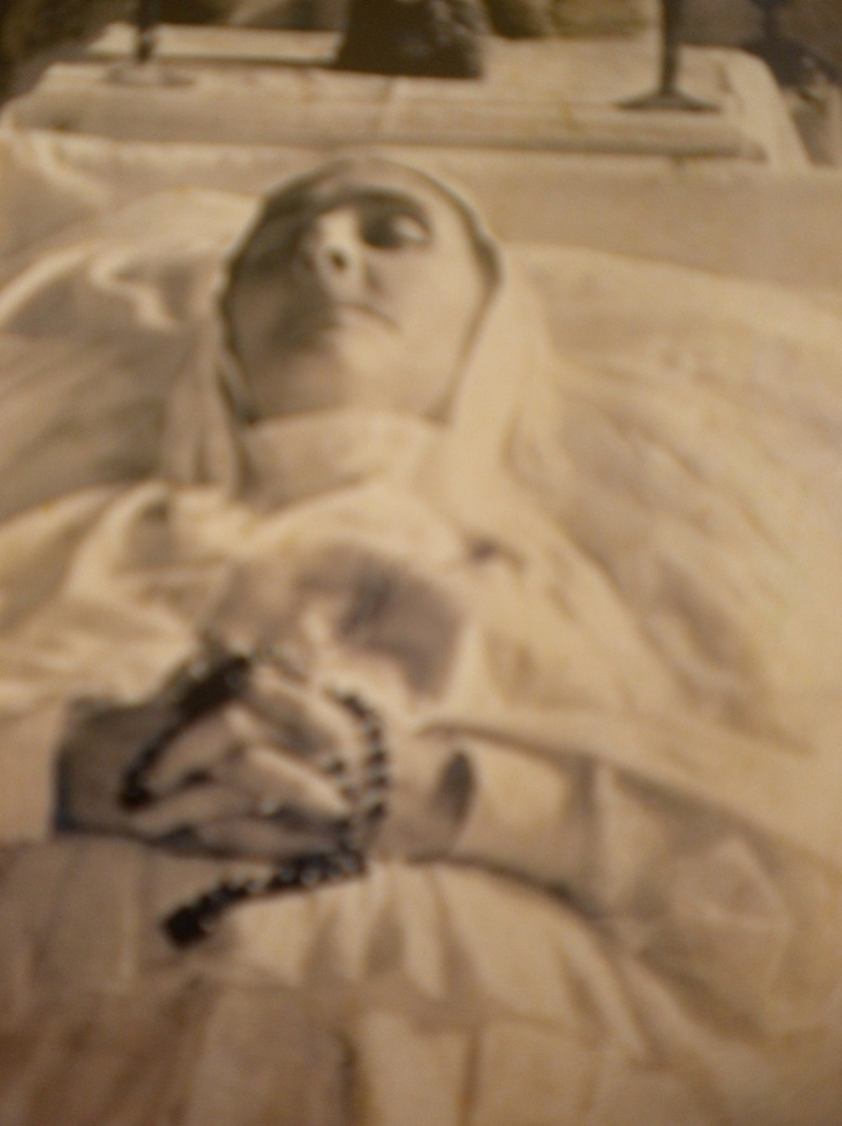

Though the body of this heroic missionary was taken to Nagpur (India) where she was inhumed in the chapel just in front of the altar, it is consoling to think that the spirit of our Beloved Mother lives in Bangladesh. It was a heart breaking events for the Sisters of Dhaka. However, by losing one life she produced hundreds souls to continue her mission for the greater glory of God. She is very much present in Bangladesh. She continues to accompany us in a special way, inspiring us with the passionate love for the Lord and a compassionate love for all God’s children.

Few years after the death of Mother Marie Gertrude

Mother Vincent of the Holy Spirit passed away on March 25th 1909. Periodically terrific epidemics reappear. In the first hours of March 25th 1909 Sister Pauline of the Eucharistic, a very young Sister felt the first symptoms of the dreadful scourge cholera. The Civil Surgeon summoned at once was powerless and the sister calmly prepared for death, assisted by Father Crowley who in leaving the room said with deep emotion: ‘she is admirably prepared;’ She expired in the evening, her absolute submission to the will of God made the admiration for all those who witnessed her last offering. Sister Therese seriously attacked by pneumonia also breathed her last in May 1909.

Added to all these Bishop Hurth who had brought the first seven sisters to Dhaka resigned in February 1909 and one month later the new Bishop Frederic Linneborn CSC became the third Bishop of Dhaka. We have but few details on the subsequent years. In some notes it is mentioned that at the Bishop’s request, the CMMI went to Golla and Husnabad. They were taking care of the school in the mornings and visiting villages in the afternoon. Their apostolate was flourishing in Dhaka city as well as in the villages across the Burigonga, besides the English Medium School and dispensary at Luxmibazar and the Poor House at Ramna.

Since they were called back to France, they handed over St Xavier’s Convent, Luxmibazar to the Congregation of Our Lady of Notre Dame of Missions (RNDM). They served there till May 1912. Among the SMMIs who were in Dhaka, some returned to France, some went to Guwahati, Kumbakonam and Nagpur.

SMMI Charism remained alive in Bengal (Bangladesh)

One may wonder how could such bright hopes vanish and all these works come to an end in 1913?
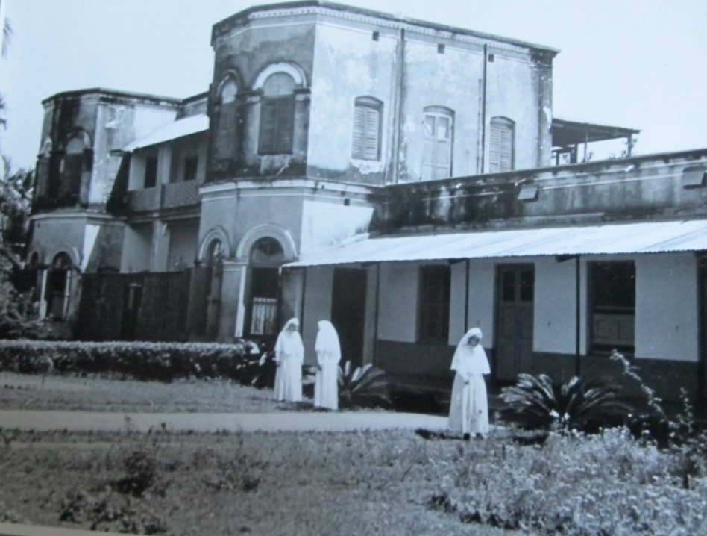
The Lord’s plans are not ours. He was preparing another field, fitting better with the charism entrusted to the Institute by the Founders. The seed that our Pioneers have sown (between1896 – 1912) through their lives gave its fruits that our sisters were called back to Bengal to work among the people in Mymensingh district, under Dhaka Archdiocese.

Therefore in 1928 on 10 February, Bishop A. Legrand CSC, Bishop of Dhaka approached the Major Superior in Paris to send SMMI Sisters to work in Mymensingh area among the Tribal people. Once again after sixteen years of gap our Sisters: two of the previous group: Sr Madeleine Caroline and SrBerchmans of the Eucharist and two new ones: Sr Marie Marthe of the Emmanuel and Sr Marie Jean arrived in Mymensingh on 10th February 1928. The group was strengthened soon by the arrival of Sr Xavier and Sr Therese of the Tabernacle from Nagpur who also were belonged to former group.
It is good to mention that Brother Eugine CSC who was appointed by the Bishop to study the situation of that new area of Mymensingh was the Bengali teacher of the first CMMI (SMMI) Sisters during the first year of their arrival in Dhaka and who worked with them about one year in Luxmibazar felt that this new evangelization area would be very much fitting with the charism of SMMI so, he proposed to the Bishop to call back the SMMI Sisters for this new Evangelization.

The SMMI’s charism is to work in non-evangelized area, mainly the apostolate of women, had the grace to work in Mymensingh mission at first through their apostolic tour to far villages. During their visit the sisters could experience the joy of finding many women, receptive to the grace, open to the message of the Gospel and in their turn ready to be apostles among other women of the villages.

Our apostolate

Keeping in mind the charism of our Institute we try to reach out to the people of all faith, race and colour, giving the special attention to women and children. The Sisters run schools, dispensaries, needlework centres, conducting social welfare activities, give adult education, youth formation, holy-childhood, family visit, in social pastoral centre and in the Bishop’s house of Mymensingh and Chittagong Archdiocese.
In 1976 for some reasons the name of the Institute was changed only for Bangladesh. The name Salesian Missionaries of Mary Immaculate was replaced officially by Salesian Sisters of Mary Immaculate (SSMI).

The Communities and Activities

1. Holy Family Convent, Mymensingh

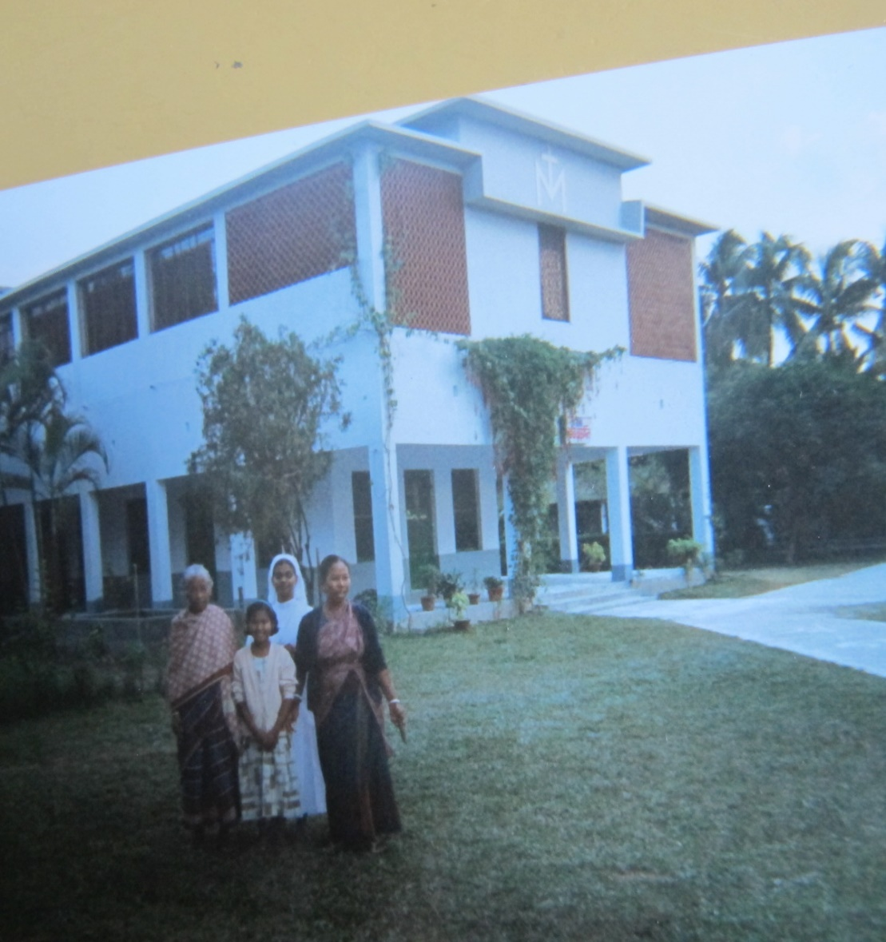
In February 10, 1928 by the second coming of the 4 SMMI pioneers: Sr Madeleine Caroline, SrBerchmans of the Eucharist, Sr Marie Marthe of the Emmanuel and Sr Marie Jean, the Holy Family Convent was initiated. The following day the first mass was offered in a place where at present it is used for sacristy cum parlour, to mark the foundation and to thank our Lady of Lourdes on her feast day on 11 February 1928 and thus officially installed. This house is the centre for the second foundation of SMMI in Bangladesh.

Soon Sisters engaged themselves in learning local languages, culture of the people and tried to enter into the hearts and minds of the people through their very way of life. After a year on 11 February 1929 the Blessed Sacrament was installed in the small chapel. Then to give importance to the value of education on the second anniversary of their arrival on 11 February 1930 a small boarding was blessed naming St Theresa of the child Jesus with 8 girls. At the same time a primary school also was started in that same building. During the day using for the school and during the night for the boarding girls till a building with tin roof was built and blessed on 21 December 1939 and named Holy Family Girls High School. A dispensary was opened to take care of the poor people especially the women and children near the gate. In the same year on 18 June 1930 at the request of Bishop Crowley, sisters went to teach in Nagori School and on 20 December, after six months of service they handed over the school to Holy Cross sisters and returned to Mymensingh. On 5th October 1931 the construction of grotto started and on 22 December at 8:00 a.m. Priests, sisters with all the inmates, our Lady of Lourdes was taken in procession and prayer and thus installed and blessed.

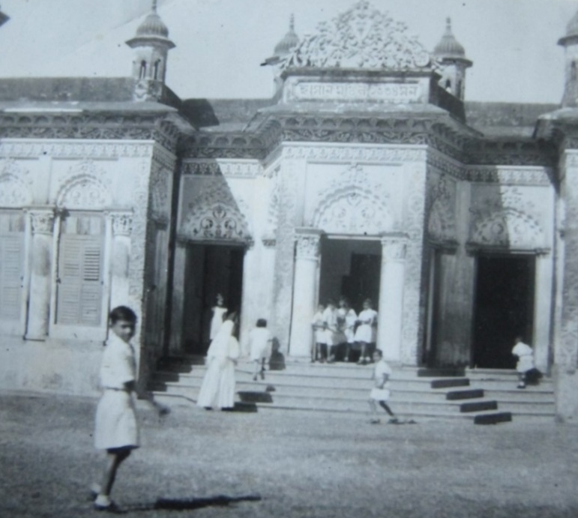
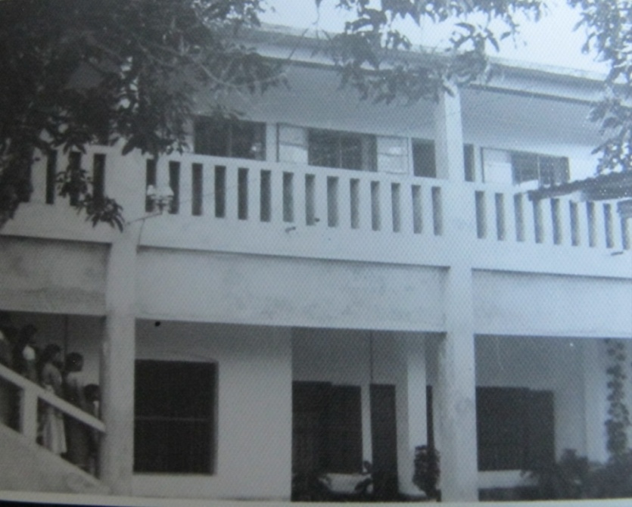
In 1940 Sr Marie opened a needlework-centre to support the poor and the needy women. It was found that the little benefit they received from the needle work centre, they donated the amount to serve the victims of the Second World War.
They also took active part in the parish activities such as: to take catechism classes, marriage preparation, family visit, etc.
A new house was built to shelter the women who used to come for treatment and also a new chapel was built and blessed in 1940.
In 1943 there was an epidemic so from the government hospital in Netrokona there was a request that our sisters go and serve the patients. In response to this, Mother Louis went to serve there for six weeks in September 1943.

Formation

Sisters thought of recruiting local girls who desire to join us thus on 28 December 1931 two candidates and then in the beginning of 1932 two candidates, after a few days again three candidates joined. On 23rd December 1935, a novitiate with a semi-pucca building with a tin roof was blessed at Mymensingh. Mother Louis was the first novice mistress. But at the same time the local Congregation called (SMRA) was just to be founded and for this purpose the Bishop with the help of Holy Cross sisters wanted to start a novitiate. So he asked SMMI to close the novitiate and asked our novices to join the Congregation of SMRA at Toomiliah. Among seven novices four of them joined the SMRA and three others went back to their home.

Then with the permission of Rome in 1962, a novitiate was reopened to join SMMI. On 19 March 1963 at St Patrick’s church, presently St John Paul hall, the first vestition ceremony was presided over by Mgr T. A. Ganguli. The following were to start their novitiate: Sr Rose Mary of the Cross and Sr Mary Dango of the Immaculate. On that same day the two storey school building also was blessed in the school compound. From that on the novitiate continued but then in 1976 novices were sent to Kengeri. Again due to visa problem from 1980 to ’83, the novitiate was in Bangladesh. Then again from 1984 onwards novices were sent to Kengeri.

At present at Holy Family Convent there are about 150 girls of primary, high school and college students where they are getting opportunity to have better academic education, human, moral and spiritual formation by our Sisters. Our Candidates those who are discerning their vocation, they also stay here and do the college studies.

Holy Family School was upgraded from primary to high school but due to some unavoidable reasons from 1977 onwards slowly the high school was closed; only the primary school existed up to 2007. Again at the request of some local people, the school is upgraded to high school since 2008.

English medium school

At the request of some people and to support the communities, an English medium school was first started in Holy Family convent in 1950. Later it was shifted to ‘Ahsan Monjeel’ in Kacharighat near the river bank of Bhramaputra named “Myriam School” with 30 students. Sr Marie Hélène of the Christ was the Principal of “Myriam School”. It was blessed by Bishop Granner on 14 January 1955. After the liberation war the government asked to close the English medium school thus it was closed in 1972.
Sisters are involved in parish and diocesan activities through different commissions of the diocese.

2. Mary Immaculate Convent, Biroidakuni

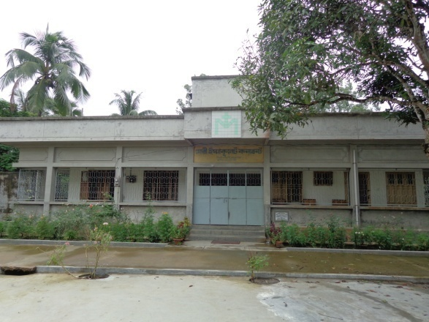
On 07 January 1931 Sr Xavier and SrBerchmans of the Eucharist left Mymensingh to open a new Convent which is called ‘Convent of Mary Immaculate’ Biroidakuni. It is good to mention that on 24 May 1939 from MymensinghSr Xavier with one girl Joanna Mree went to Biroidakuni by bullock cart. They spent the night at Phulpur and started their journey the following day by bullock cart and reached Biroidakuni in the evening. Since then the area of apostolate was very much extended and it was the largest parish in Bangladesh. In 2006 Joljolia was bifurcated from Biroidakuni and became a new parish.
In this parish, besides the village apostolate, Sisters look after the primary and high school girls’ hostel and work in the dispensary. Through our dispensary every year Sisters arrange health care seminars in different centres. Our French Sister Paul Neau worked for many years in this area. Every day she used to go to visit villages by bicycle and helped the poor. She purchased some land for sponsored children and settled them in different villages. When Sisters go to the villages, people still recall her good work.

3. St Joseph’s Convent, Bhalukapara

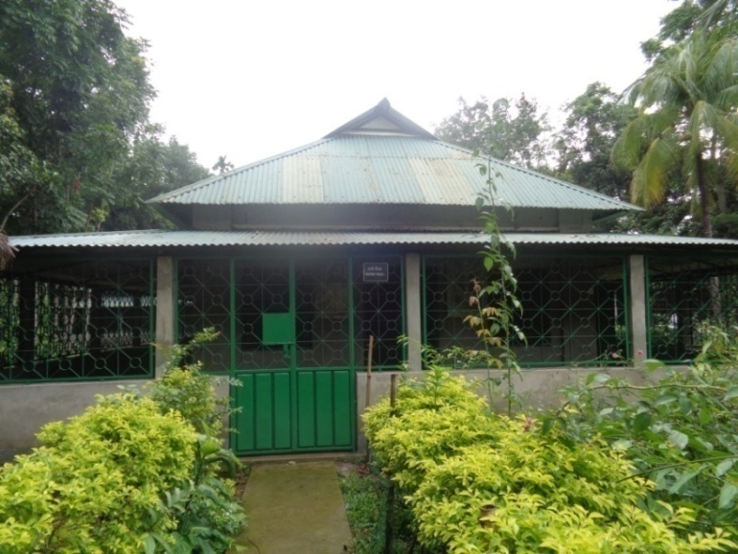
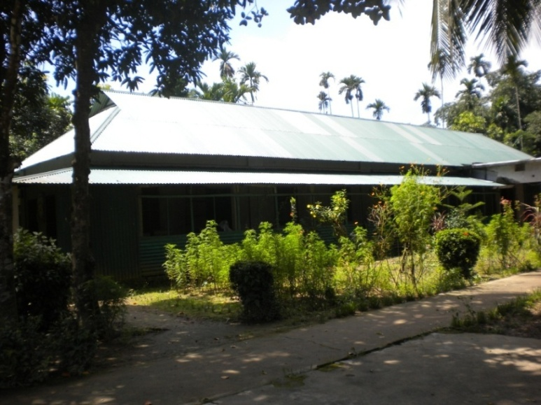
This convent was started on 01 January 1933 by Sr Xavier of the Eucharist and Sr Marie Marthe of the Emmanuel. As it is very close to the hills, jungles and river, people would go to work to the hills and jungles and drink river water and easily used to get sick especially they were attacked by severe typhoid, malaria, diarrhoea, snake bite, etc. So a dispensary cum maternity was started by Sr Genevieve Bonte where many children and mothers’ lives were well taken care of and rescued from dangers. Since it is situated far from the city and close to the India border, till today this convent is serving many people specially the pregnant mothers, children of the area even few come from India to our dispensary and get good care from our Sisters.

We have boarding for boys and girls for primary and high school. Every year about 100 children are accommodated in the boarding. In order to help the women, we have sewing centre where about 35 ladies (Garo and Hajong) those who have families, who cannot go to work to the city, come and do embroidery here. Sisters also teach in the parish school and regularly do village apostolate.

Ranikhong Convent

Ranikhong is the first parish in Mymensingh area started in 1910. This parish is situated on the top of a hill, close to a big river Someshawri originated in India. Its natural beauty is very much attractive, eye-catching but very far from the city and for communication it is very difficult. Most of the people live in far villages. SrMarthe and Sr Therese Marie were the pioneers to open a new Convent in Ranikhong on 21 January 1936. With the help of Father Rick CSC our Sisters visited the villages with bullock cart. They taught catechism, worked in the dispensary, distributed medicine in the villages. People were very much pleased with our Sisters but for lack of personnel after almost 28 years of hard work in August 9, 1963 our Sisters handed over this house to the local Congregation (SMRA) and came back to Mymensingh. This parish has celebrated the 100 years centenary in 2010.

4. St Raphael Convent, Baromari

Baromari is situated at the Northern part of Mymensingh district (now in Sherpur district,) close to India border. At present there is a check-post named Lakugaon. Baromari mission is on the top of a hill surrounded by the many hills, jungles and a river, coming from India too. Every year the people of this area are strongly affected by the wild elephants, flood and other natural calamities.
Sr Therese and Sr Marie Immaculate went to Baromari mission in October 1945 and on 18 Nov. 1946 the Convent of St Raphael, Baromari was officially inaugurated. Like the other places here also people were in need of proper medical care, academic as well as moral and spiritual support as this place also was in a very remote area. From the beginning of their stay sisters devoted themselves to fulfil basic needs of the people and tried to give Christian faith among the people. They opened a small clinic cum maternity.
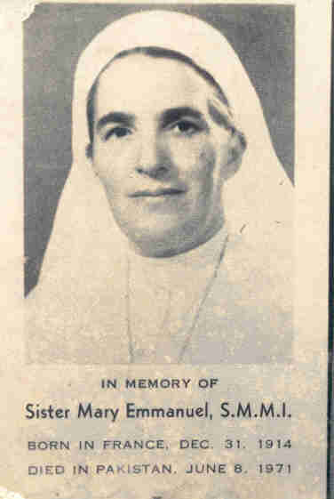
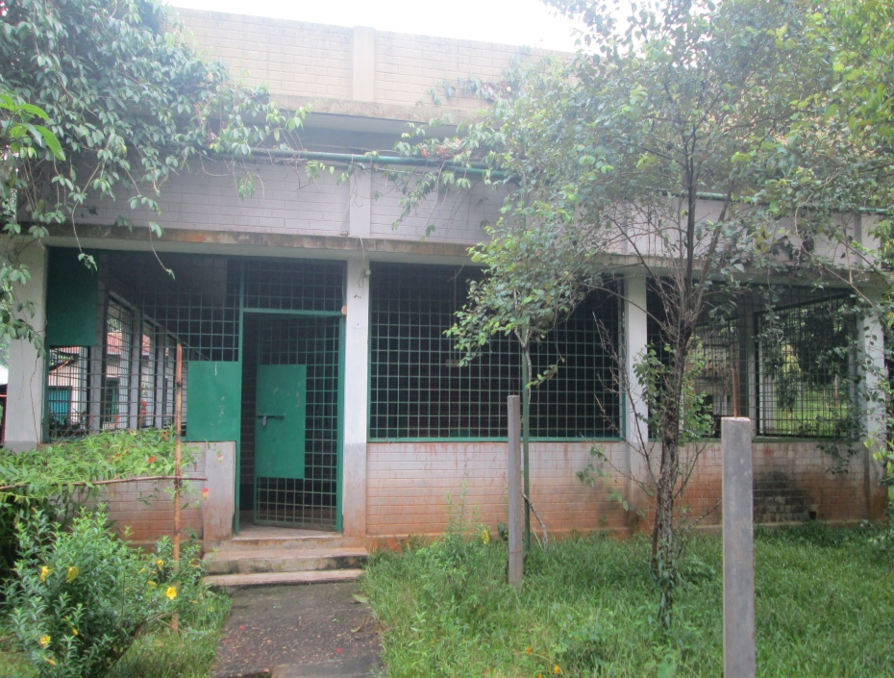

During the war of 1971 our Priests and Sisters were in great danger. All the French Sisters were brought back to Mymensingh. But our beloved courageous Sr Immanuel (French) who was known as a doctor sister remained there to serve the patients. Unfortunately, during the liberation war in 1971 she died in a mine burst on the way to Nunni. She offered her life for our country. We are very proud of her sacrificial life.

At present sisters teach in the parish primary and junior school, look after the primary and high school girls’ hostel and participate in the parish activities.
Since the year 2000 Baromari is known as a pilgrimage place of our Lady of Fatima. Many people come for the pilgrimage throughout the year. Every year, the last Thursday-Friday of the month of October Mymensingh diocese celebrates Annual pilgrimage at our Lady of Fatima shrine in Baromari so from all over Bangladesh thousands of Christians and even non-Christians come to pay their special devotion to our Mother Mary. Our Sisters take active part in it and take care of the pilgrims too.

Mariamnagar Convent

Mariamnagar means a city of our Lady, is in Sherpur district, close to Baromari mission. Sr Paul Juliette and Sr Marie Agnes were the pioneers to start this convent on 14 February 1952. Like the other places Sisters had a boarding for girls and a dispensary but unfortunately due to lack of personnel by the advice of Bishop, on 10 January 1964 our Sisters handed over this beautiful house to the local Congregation (SMRA).

5. Salesian Sisters’ House, Monipuripara, Dhaka

From the beginning of the second foundation (1928-1978) we did not have any house in Dhaka. Since it was the capital of the country and Mymensingh being under the Dhaka Archdiocese, our Sisters often had to make a trip to Dhaka for any official business. Sisters not having any house had endless suffering and each time they had to take trouble for seeking accommodation. Meanwhile, people of Mymensingh area especially the girls were migrating to Dhaka to work in garment factories, Beauty Parlours and as the house maid. So Sr Genevieve Bonte with a full encouragement and support of Mother Louis, at the then Provincial, the plot with a small house was purchased and the community was installed on 24 Jan. 1978. Later the house was built for needle work center and blessed by his Excellency Pro-nuncio, assisted by Fr Zimmerman on 28 May 1981.

Dhaka was opened with three-fold purposes:
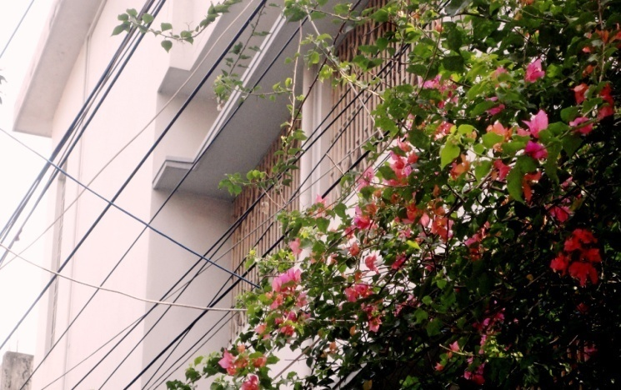
First: to take care of young girls (Garos) who are working in Dhaka, to give shelter for a short stay to thosewho come for the treatment or to seek for a job from Mymensingh. In the beginning some boys were there to learn handicraft.
Second: to give formation to the young girls and to recruit vocation of the candidates.
Third: for the spiritual improvement of the local area, our sisters go regularly for family visit, prayer, mass, rosary prayer, etc. People appreciate such apostolate. The Society of the Daughters of St. Francis de Sales is initiated to our women by Sr. Joseph. At present there are 66 consecrated Daughters and some others are under formation. We have daily mass in the chapel it is open to our neighbours especially to the old and sick people. We have embroidery centreand the hostel for college girls.

6. St Martha’s Convent, Baluchora
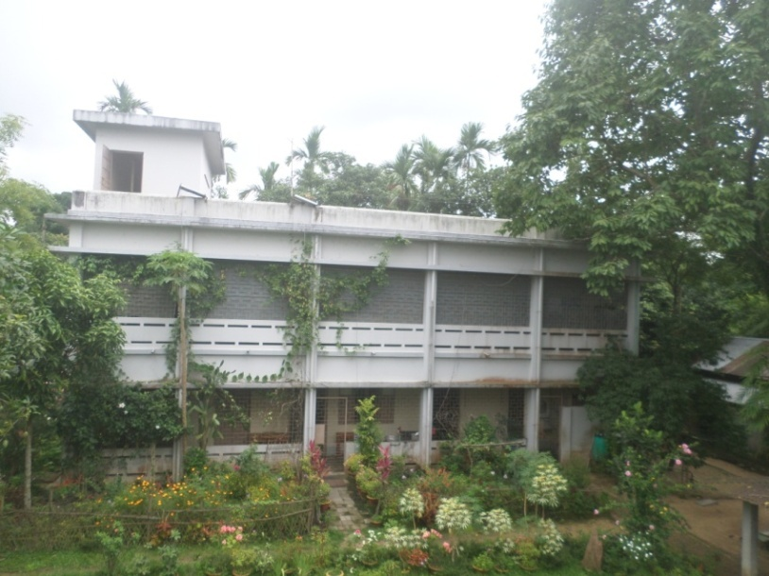
Baluchora mission is situated in Netrokuna district, close to the border of India. Sr Augustine and Sr Maria were the pioneers to open a new convent there in 01 January 1985. In the beginning they stayed in an old semi-pacca building and were fully involved in parish pastoral activities. Slowly they felt the need to start a hostel for the girls who come to parish school from far villages. So, two new buildings for primary and high school girls and another for sisters’ accommodation are built. Every year about 80 girls are accommodated in our hostels. Sisters visit villages, take catechism classes in the school and take care of these hostellers.

7. St Jane de Chantal Convent,Mugaipar, Sunamgonj

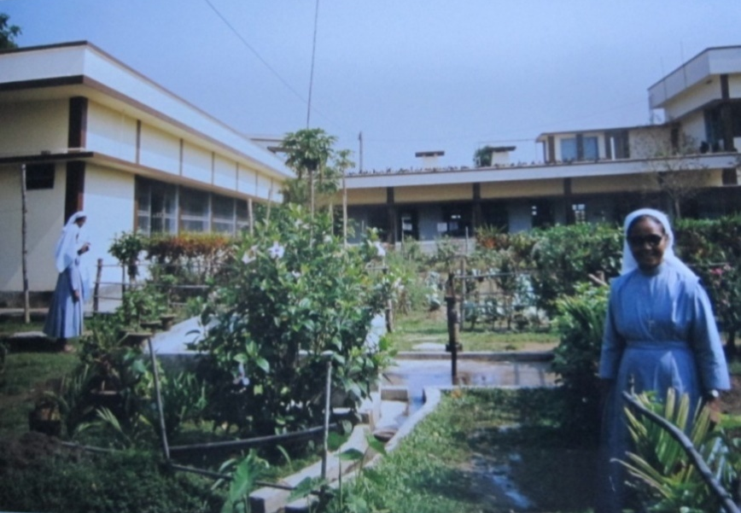
Responding to the call of the Archbishop Michael Rozario, DD and Oblate of Mary Immaculate Fathers, Sister Augustine, Sr Mary Anthony and Sr Reena Cecilia were the pioneers to open this new convent on 23 January 1994. At that time Mugaipar was under Dhaka Archdiocese situated in a remote area of Bangladesh-India border. A new diocese Sylhet was erected on 30 September 2011, since then it is under this new diocese. Here our main apostolate is medical care through our dispensary cum maternity, teaching in the diocesan high school, looking after the hostel and village apostolate.

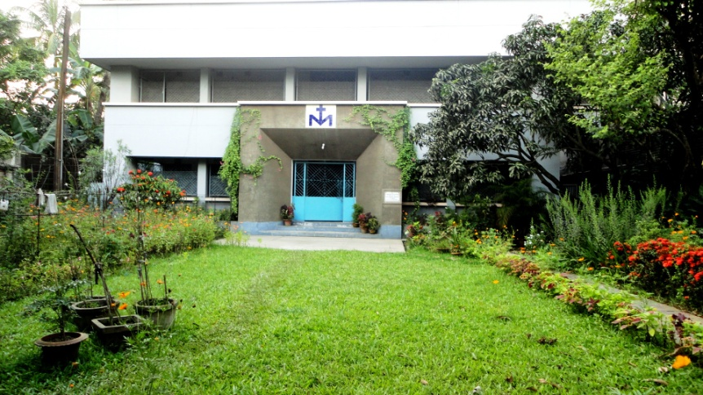
8. Salesian Formation House, Korunaloy

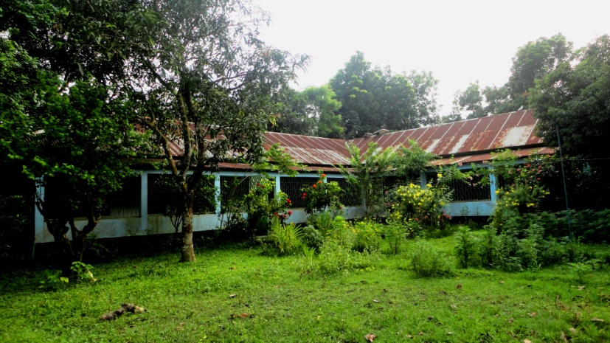
In the beginning this house was meant for embroidery center run by Sr Genevieve Bonte. After her tragic death in 1988 this house was used for patients coming from different missions/villages for better treatment in the medical Hospital. For the patients it is now used next to this compound at St Vincent’s clinic. This house is turned into Salesian Formation House since 15 Jan. 1991. After a new construction in 1998, the novitiate is shifted to this house from Holy Family Conventon20 March 2003. As a community, it was installed on 28 July 2008.

9. Holy Angels’ Convent, Noluakuri

This community is in between Mymensingh and Dhaka, sub-parish of St Patrick's Cathedral, Mymensingh. Around 1996 Sr Cecilia with Fr Tonino, a Xaverian Priest had started social work among the people of the area especially among the non-Christian women staying in a hut of a Christian family. Later Sr Augustine joined her for the apostolate. They had projects for women’s adult education, handicraft center, teaching in the junior school and looking after the pre-primary to high school children. Thus slowly these women became aware of their rights and dignity. In 2001 Sisters had a permanent house thus a community is installed on 26 March 2008 atNoluakuri. Sisters take active part in the parish activities: preparation for the Baptism, first Communion, Confirmation and marriage. Recently, ‘Fr Tonino Memorial Clinic’ run by a lay man, is purchased, now sisters are responsible and serving through this clinic.

10. St Francis de Sales Convent, Thanchi

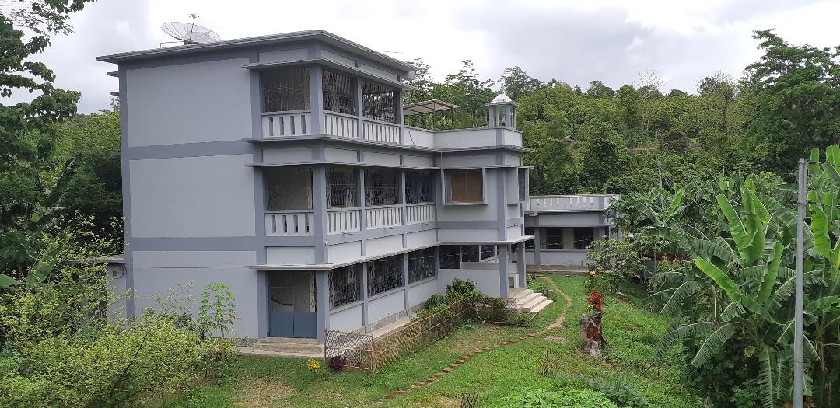
At the invitation of Bishop Patrick CSC, the then Bishop of Chittagong on 21 April 2002 Salesian Sisters opened this new Convent in the interior place of Thanchi to work among the Tripura, Murma, Chakma, Bom, Khumi and Murong people. Thanchi Mission is situated in Bandarban district, on the hill top and close to Burma / Myanmar border. Communication is the most difficult; to reach out to our convent. Since 1950 these Tripura people were baptized by the Holy Cross Fathers but after that there was no follow up due to tropical diseases like malaria, typhoid and jaundice. Fortunately, they kept up their Christian faith and welcomed the Sisters to revive their faith. In the beginning most of our Sisters were affected by this terrible malaria. With the grace of God, Sisters have taken this challenging mission to work among these people. Sisters are working in collaboration with the Priests and people, visit villages, teach in the parish school, work in the dispensary and look after the hostel boys and girls.

11. SMMI Convent, Chittagong
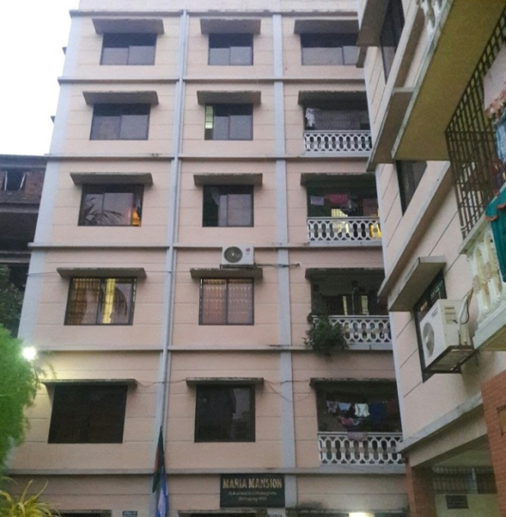
To support Thanchi Sisters especially during their sickness if they need to come to the city for a better treatment, a small community was opened in an apartment (given by the Bishop) in Chittagong town in 2007by Sr Augustine, Sr Lina and SrSuffolaElizabeth.As a community, it was installed on 24 Jan 2015. One Sister had been working in the diocesan hospital; presently, due to lack of personnel (nurse sister) no one works there. Two sisters work in the Archbishop’s house as a secretary and an accountant. One sister accompanied by turn with another sister do regular visitto the girls who are working in beauty parlours, garments and in the houses. In Chittagong City about 3 thousand Garosare working in different factories, garments, company, offices, beauty parlours, etc. Sisters are trying to keep contact with the owner and arrange classes for initial sacraments: prayer, catechism, sacrament of reconciliation, Holy mass, and listening to their problems, accordingly tryingto bring justice to workers for their human rights, especially to have just wages.

12. Our Lady of Fatima Convent, Luxmikul

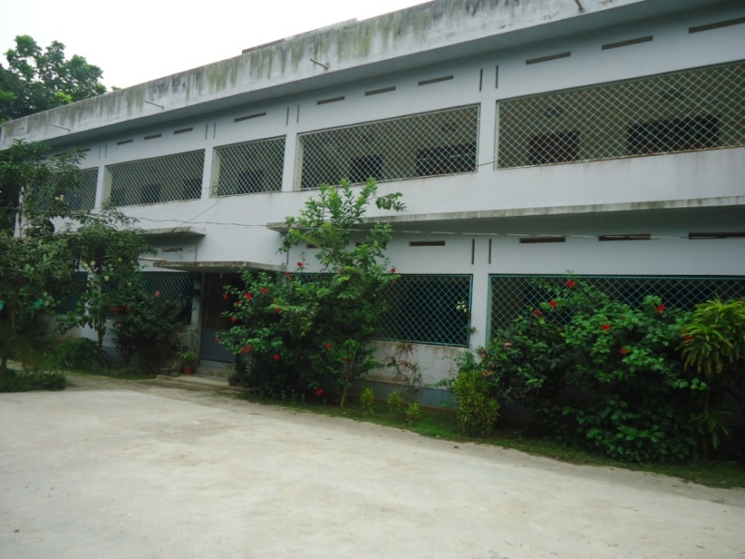
In response to the invitation of Bishop Gervas, Bishop of Rajshahi, Salesian Sisters opened this new convent on 26 July 2009. Before the installation, sisters have visited the parish and prepared the parishioners during Advent and Lent seasons since 2007. Our Convent is far from Rajshahi town, it is in a remote area. In the beginning SrElsy Rose, one of our Indian Sisters and three young Sisters worked hard among the Uraon and Shantali people. People were not familiar with us, we were strangers to them. Our continuous visit and efforts made them to understand who we are.
We have health education seminars in the center as well as in the villages.
We started small hostel with 10 girls in 2010. Children studied in the Brac School. Now we have new hostel building where 60 children can be accommodated. At present we have new play ground with different playing materials for their physical exercises. We all are happy in our mission and our apostolate.
Sisters have active participation in the diocesan programmes, specially youth animation, holy childhood, catechism, seminar, retreat, vocation promotion seminar, etc. We have common celebration and get together during Christmas, Easter and Patron Saint’s feast of the church and share meal together by the contribution of the parishioners.

13. St Michael Convent, Katadanga

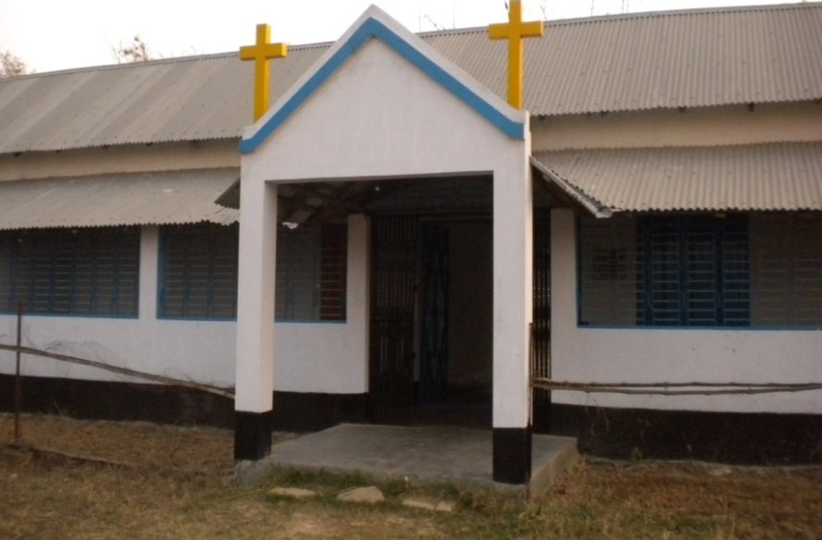
At the invitation of Bishop Gervas, Bishop of Rajshahi and the Parish Priest Fr Henry OMI, a second community,St Michael’s Convent was installed in Katadangaparish, on 8 January 2012. The pioneers wereSrPritiDominica,Sr Lila Cecilia and SrShakhiMartha.
Sisters are working mostly among Santal, Uraon and Mahaliadibashies. It is a new evangelization area, recently started by OMI Fathers.
There is only a tin shade building; in one part there is a small dispensary and in the middle we keep 10 small children and the other part is the Sisters’ rooms, chapel and refectory.
In 2013, SrDipali was appointed for the administration of the junior school, presently it is upgraded to High school. Though it is a very challenging area, peoples are very co-operative with our sisters so sisters are happy with their ministries.

14. Sacred Heart Convent, Radhanagar

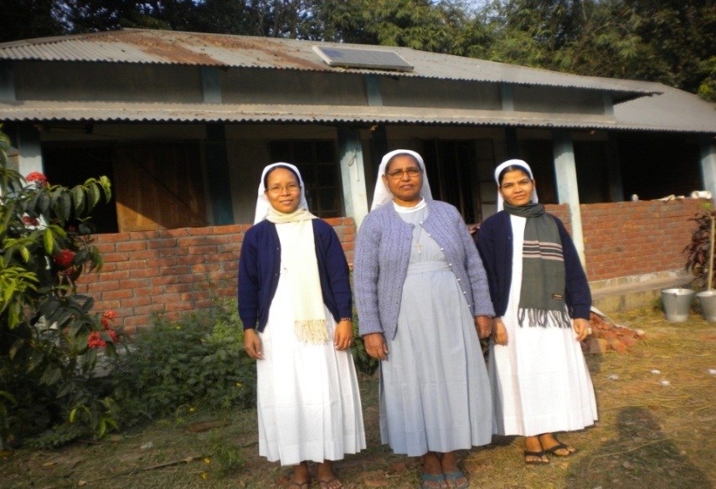
Sacred Heart Convent at Radhanagarparishwas opened on 7 December 2014.The Pioneers were Sr Mary Anthony, SrAgnes Soren and SrDipti Rema.
There is a hostel for girls. There was a primary school which is presently upgraded to junior high school. Two sisters are in administration and teaching in this school. There is a demand from the people to upgrade the school to high school and to open a dispensary. However, Superior, being a nurse sister, dispenses medicine to the sick people when she goes to visit villages.
Like other places, sisters do regular family visits, education, health care, faith formation, and social development, etc.

15. Asha Griho, Parartek

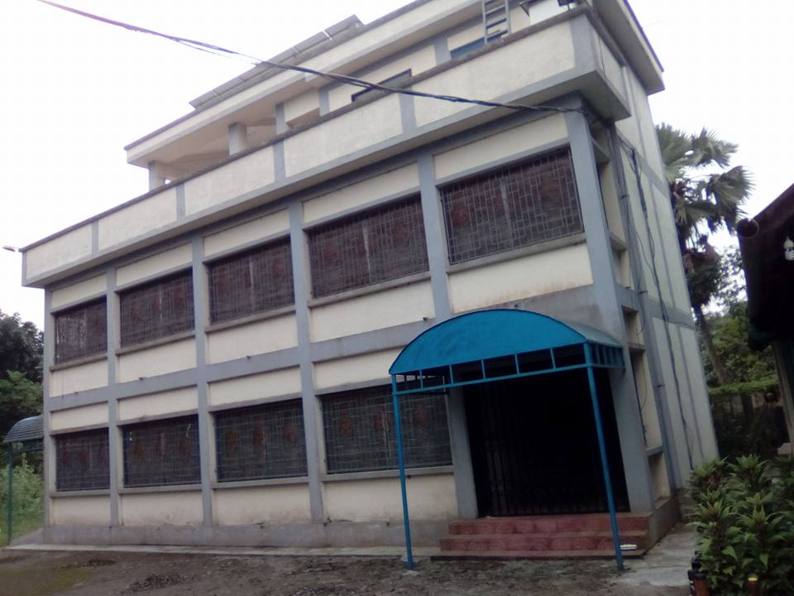
Parartek is a sub-centre of St Nicholas Parish, Nagariwhich was developed by the Kottognae Sisters from Korea who lived there from 2006 to July2016.
It was handed over to SMMI in February 2017, the sisters of this center are attached to the community of Salesian house, Monipuripara, Dhaka. The pioneers are Sr Josephine, SrMary Florence, SrBidima and Sr Bely Jacinta.
There is a primary school and a day care center for physically challenged people.
Thereis a small chapel for the use of the people around which is maintained by the Parish.
One sister is responsible for Day Care Center for physically challenged persons. She works under the direction of BishopEmeritus, BpTheotonius Gomes, CSC.
One sister is responsible for the School which is found outside the campus.
One sister is responsible for pastoral activities in close collaboration with the Parish Priest.



The Congregation of Holy Cross in East Bengal, 1853 - 1953 volume 1 & 2.
_{Ibid.}
The Congregation of Holy Cross in East Bengal, 1853 - 1953 volume 1 & 2.

